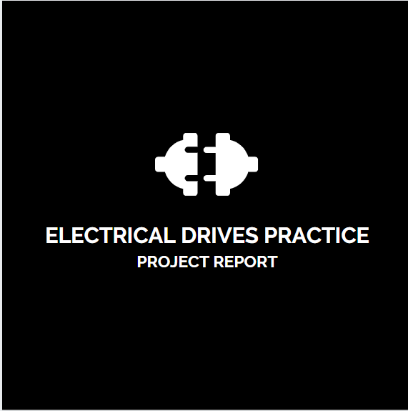**ELECTRICAL DRIVES PRACTICE**

**PROJECT REPORT**

**PRESENTATION TITLE:** Solar based Mobile Charger

**COLLEGE:** Indian Institute of Information Technology Design & Manufacturing, Kurnool

**STUDENT LEVEL:** Graduation

**PRESENTATION TYPE:** Oral

**PRESENTATION AT:** IIITDM,Kurnool

**KEYWORDS:** photo-voltaic cells, buck boost converter,lm2576

**ABSTRACT:**

With the existing energy in the direction of utility, clean sources of power, it is no surprise that solar power has become one of the most popular alternative energy sources. Free and available everywhere, the power of the sun can be employed to power everything like mobiles and MP3 player. The sun's energy is usually gathered through solar panels that are made up of photovoltaic cells. These cells can convert the sun's power into electricity that can be used for a number of purposes. For private use, a handheld solar hybrid charger can be employed to recharge little device for instance a MP3 player, a cell phone, or a camera.

A normal PN junction diode is used for unidirectional flow of charge current. The output of the solar panel depends on the intensity of the solar light.To regulate this voltage,buck boost converter comes into handy. It boosts the dc voltage when it is below 5V and bucks the dc voltage when it is above 5V according to the duty cycle of the switching.Therefore we use the buck boost converter in closed loop to regulate the voltage to 5V .

To regulate this voltage, LM2576 is used. LM2576 is a simple switcher IC used in the construction of a buck converter. The circuit is designed to get a fixed voltage of 5V with 3A current.

**BLOCK DIAGRAM:**

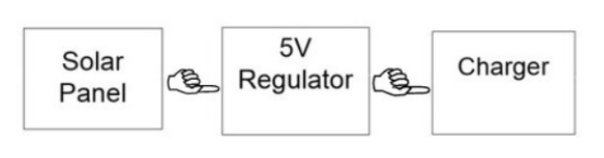

**1.1 INTRODUCTION:**

Given the current energy crisis and increasing need for sustainable energy, we endeavored to create a cost-effective, small-scale electrical generator which could be used to power consumer electronics. Solar energy has proven its worth as an alternative energy source because it is low-impact and emission-free. It has been implemented with much success for power grids with hundreds of acres of enormous solar concentrators. In the small-scale, solar energy has been harvested through the use of photovoltaic (PV) panels and have been used to power anything from an iPod to a residential home. Although PV systems are considered part of the green energy revolution, materials utilized for its construction (like silicon) are extremely dangerous to the environment and much care must be taken to ensure that they are recycled properly. PV cells also only utilize the energy stored in specific wavelengths of light and therefore have an approximate efficiency between 14-19%. Sunlight, however, produces immense amounts of heat which only serves to heat up the surface of the solar cell. Although there are some PV cells that have reached efficiency levels over 40% (world record is 41.6%), they are enormously complex and expensive.

Concentrated solar power (CSP) works differently because it focuses solar energy in its entirety rather than absorb it.

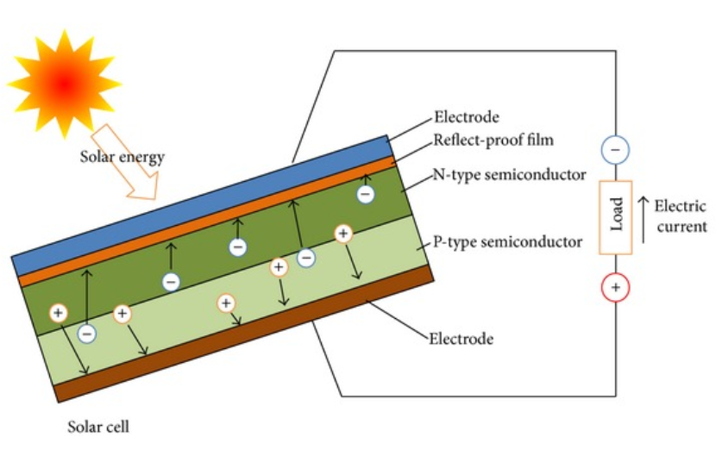

The term "photovoltaic" comes from the Greek (photo) means "light", and "voltaic", means electric from the name of the Italian physicist “VOLTA "after whom a unit of electro-motive force, the volt is named. The sun is a star made up of hydrogen and helium gas and it radiates an enormous amount of energy every second. A photovoltaic cell is an electrical device that convert the energy of light directly into electricity by photovoltaic effect. Photovoltaics is the field of technology and research related to the practical application of photovoltaic cells in producing electricity from light, though it is often used specifically to refer to the generation of electricity from sunlight. Cells can be described as photovoltaic even when the light source is not necessarily sunlight (lamplight, artificial light, etc.). In such cases the cell is sometimes used as a photodetector (for example infrared detectors detecting light or other electromagnetic radiation near the visible range, or measuring light intensity.

The operation of a photovoltaic (PV) cell requires 3 basic attributes: The absorption of light, generating either electron-hole pairs or excitons. The separation of charge carriers of opposite types. The separate extraction of those carriers to an external circuit. In contrast, a solar thermal collector collects heat by absorbing sunlight, for the purpose of either direct heating or indirect electrical power generation. "Photo-electrolytic cell" (photoelectrochemical cell), on the other hand, refers either a type of photovoltaic cell (like that developed by A.E. Becquerel and modern dye-sensitized solar cells or a device that splits water directly into hydrogen and oxygen using only solar illumination. Photovoltaic power generation employs solar panels composed of a number of solar cells containing a photovoltaic material. Materials presently used for photovoltaics include monocrystalline silicon, polycrystalline silicon, amorphous silicon, cadmium telluride, and copper indium gallium selenide/sulfide.

Due to the increased demand for renewable energy sources, the manufacturing of solar cells and photovoltaic arrays has advanced considerably in recent years. Solar photovoltaics is a sustainable energy source. By the end of 2011, a total of 71.1 GW had been installed, sufficient to generate 85 TW/year and by end of 2012, the 100 GW installed capacity milestone was achieved. Solar photovoltaics is now, after hydro and wind power, the third most important renewable energy source in terms of globally installed capacity. More than 100 countries use solar PV. Installations may be ground-mounted (and sometimes integrated with farming and grazing) or built into the roof or walls of a building (either building-integrated photovoltaics or simply rooftop).

Driven by advances in technology and increases in manufacturing scale and sophistication, the cost of photovoltaics has declined steadily since the first solar cells were manufactured, and the leveled cost of electricity (LCOE) from PV is competitive with conventional electricity sources in an expanding list of geographic regions. Net metering and financial incentives, such as preferential feed-in tariffs for solar-generated electricity, have supported solar PV installations in many countries. Current technology, photovoltaics recouple the energy needed to manufacture them in 3 to 4 years. Anticipated technology would reduce time needed to recoup the energy to 1 to 2 year.

Solar energy is the energy produced directly by the sun and collected elsewhere, normally the Earth. The sun creates its energy through a thermonuclear process. The process creates heat and electromagnetic radiation. Only a very small fraction of the total radiation produced reaches the Earth. The radiation that does reaches the Earth is the indirect source of nearly every type of energy used today.

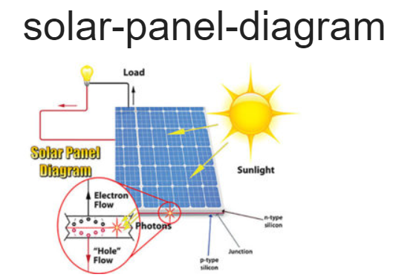

**LITERATURE SURVEY:**

**2.1 Hardware Components:**

1. Solar panel

2. buck boost converter in closed loop (taking feedback)

3. Resistors

4. Switch

5. Output jack

**2.1.1 Solar Panel**

A solar cell is a device that converts the energy of sunlight directly into electricity by the photovoltaic effect. Sometimes the term solar cell is reserved for devices intended specifically to capture energy from sunlight such as solar panels and solar cells, while the term photovoltaic cell is used when the light source is unspecified. Assemblies of cells are used to make solar panels, solar modules, and photovoltaic arrays. Photovoltaic is the field of technology and research related to the application of solar cells in producing electricity for practical use. An alternative charger circuit is also provided to charge the mobile by house hold general purpose 230V in the absence of the sun light. The solar panel can be used as a component of a larger photovoltaic system to generate and supply electricity in commercial and residential applications. Each module is rated by its dc output power under standard test conditions (STC), and typically ranges from 100 to 320 watts.

**Simple explanation:**

1. Photons in sunlight hit the solar panel and are absorbed by semiconducting materials, such as silicon.

2. Electrons (negatively charged) are knocked loose from their atoms, allowing them to flow through the material to produce electricity. Due to the special composition of solar cells, the electrons are only allowed to move in a single direction.

3. An array of solar cells converts solar energy into a usable amount of direct current (DC) electricity.

**Photo generation of charge carriers:**

When a photon hits a piece of silicon, one of three things can happen:

1. the photon can pass straight through the silicon — this (generally) happens for lower energy photons.

2. the photon can reflect off the surface.

3. The photon can be absorbed by the silicon, if the photon energy is higher than the silicon band gap value. This generates an electron-hole pair and sometimes heat, depending on the band structure.

When a photon is absorbed, its energy is given to an electron in the crystal lattice. Usually this electron is in the valence band, and is tightly bound in covalent bonds between neighboring atoms, and hence unable to move far. The energy given to it by the photon "excites" it into the conduction band, where it is free to move around within the semiconductor. The covalent bond that the electron was previously a part of now has one fewer electron — this is known as a hole. The presence of a missing covalent bond allows the bonded electrons of neighboring atoms to move into the "hole," leaving another hole behind, and in this way a hole can move through the lattice. Thus, it can be said that photons absorbed in the semiconductor create mobile electron-hole pairs.

A photon need only have greater energy than that of the band gap in order to excite an electron from the valence band into the conduction band. However, the solar frequency spectrum approximates a black body spectrum at ~6000 K, and as such, much of the solar radiation reaching the Earth is composed of photons with energies greater than the band gap of silicon. These higher energy photons will be absorbed by the solar cell, but the difference in energy between these photons and the silicon band gap is converted into heat (via lattice vibrations — called phonons) rather than into usable electrical energy

**Charge carrier separation:**

There are two main modes for charge carrier separation in a solar cell:

1. Drift of carriers, driven by an electrostatic field established across the device.

2. Diffusion of carriers from zones of high carrier concentration to zones of low carrier concentration (following a gradient of electrochemical potential).

In the p-n junction solar cells the dominant mode of charge is by diffusion. However, in thin films (such as amorphous silicon) the main mechanism to move the charge is the electric field and therefore the drift of carriers.

**The p-n junction:**

**Main articles:** semiconductor and p-n junction

The most commonly known solar cell is configured as a large-area p-n junction made from silicon. As a simplification, one can imagine bringing a layer of n-type silicon into direct contact with a layer of p-type silicon. In practice, p-n junctions of silicon solar cells are not made in this way, but rather by diffusing an n-type dopant into one side of a p-type wafer (or vice versa).

If a piece of p-type silicon is placed in intimate contact with a piece of n-type silicon, then a diffusion of electrons occurs from the region of high electron concentration (the n-type side of the junction) into the region of low electron concentration (p-type side of the junction). When the electrons diffuse across the p-n junction, they recombine with holes on the p-type side. The diffusion of carriers does not happen indefinitely, however, because charges build up on either side of the junction and create an electric field. The electric field creates a diode that promotes charge flow, known as drift current, that opposes and eventually balances out the diffusion of electron and holes. This region where electrons and holes have diffused across the junction is called the depletion region because it no longer contains any mobile charge carriers. It is also known as the space charge region.

**THEORY:**

Solar panels use light energy (photons) from the sun to generate electricity through the photovoltaic effect (this is the photo-electric effect). The structural (load carrying) member of a module can either be the top layer (superstrate) or the back layer (substrate). The majority of modules use wafer-based crystalline silicon cells or a thin-film cell based on cadmium telluride or silicon. Crystalline silicon, which is commonly used in the wafer form in photovoltaic (PV) modules, is derived from silicon, a commonly used semi-conductor. With a pencil, try this example to know the two types of energy. Put the pencil at the edge of the desk and push it off to the floor. The moving pencil uses kinetic energy Now, pick up the pencil and put it back on the desk. You used your own energy to lift and move the pencil. Moving it higher than the floor adds energy to it. As it rests on the desk, the pencil has potential energy. The higher it is, the further it could fall. That means the pencil has more potential energy.

**In order to use the cells in practical applications, they must be:**

Connected electrically to one another and to the rest of the system Protected from mechanical damage during manufacture, transport, installation and use (in particular against hail impact, wind and snow loads). This is especially important for wafer-based silicon cells which are brittle.

Protected from moisture, which corrodes metal contacts and interconnects, (and for thin-film cells the transparent conductive oxide layer) thus decreasing performance and lifetime. Most modules are usually rigid, but there are some flexible modules available, based on thin-film cells.

Electrical connections are made in series to achieve a desired output voltage and/or in parallel to provide a desired amount of current source capability.

Diodes are included to avoid overheating of cells in case of partial shading. Since cell heating reduces the operating efficiency it is desirable to minimize the heating. Very few modules incorporate any design features to decrease temperature, however installers try to provide good ventilation behind the module.

New designs of module include concentrator modules in which the light is concentrated by an array of lenses or mirrors onto an array of small cells. This allows the use of cells with a very high-cost per unit area in a cost-competitive way.

Depending on construction, the photovoltaic can cover a range of frequencies of light and can produce electricity from them, but sometimes cannot cover the entire solar spectrum (specifically, ultraviolet, infrared and low or diffused light). Hence much of incident sunlight energy is wasted when used for solar panels, although they can give far higher efficiencies if illuminated with monochromatic light. Another design concept is to split the light into different wavelength ranges and direct the beams onto different cells tuned to the appropriate wavelength ranges. This is projected to raise efficiency by 50%. Also, the use of infrared photovoltaic cells can increase the efficiencies, producing power at night.

To make sure we have plenty of energy in the future, it's up to all of us to use energy wisely.

We must all conserve energy and use it efficiently. It's also up to those who will create the new energy technologies of the future.

All energy sources have an impact on the environment. Concerns about the greenhouse effect and global warming, air pollution, and energy security have led to increasing interest and more development in renewable energy sources such as solar, wind, geothermal, wave power and hydrogen but we'll need to continue to use fossil fuels and nuclear energy until new, cleaner technologies can replace them. One of you who is reading this might be another Albert Einstein or Marie Curie and find a new source of energy. Until then, it's up to all of us.

The future is ours, but we need energy to get there. Energy causes things to happen around us. Look out the window.

During the day, the sun gives out light and heat energy. At night, street lamps use electrical energy to light our way. When a car drives by, it is being powered by gasoline, a type of stored energy. Food we eat contains energy. We use that energy to work and play.

**2.1.2 BUCK BOOST CONVERTER:**

**Basic Configuration of a Buck-Boost Converter**

Figure 1, shows the basic configuration of a buck-boost converter where the switches are integrated in the IC. Many of the Advanced Low Power buck-boost converters (TPS63xxx) have all four switches integrated in the IC. This reduces solution size and eases the difficultly of the design.

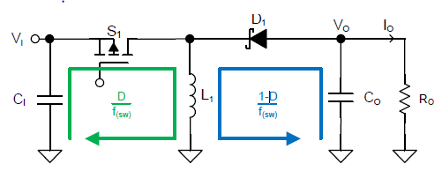

Fig: Buck boost converter schematic

**Necessary Parameters of the Power Stage:**

The following four parameters are needed to calculate the power stage: 1. Input voltage range: VIN min and VIN max,

2. Nominal output voltage: VOUT

3. Maximum output current: IOUT

4. Integrated circuit used to build the buck-boost converter. This is necessary because some parameters for the calculations must be derived from the data sheet.

If these parameters are known, the power stage can be calculated

**Duty Cycle Calculation:**

The first step after selecting the operating parameters of the converter is to calculate the minimum duty cycle for buck mode and maximum duty cycle for boost mode. These duty cycles are important because at these duty cycles the converter is operating at the extremes of its operating range. The duty cycle is always positive and less than 1.

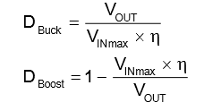

Where,

• VIN max = maximum input voltage

• VIN min = minimum input voltage

• VOUT = desired output voltage

• D-Buck= minimum duty cycle for buck mode

• D-Boost = maximum duty cycle for boost mode

• η = estimated efficiency at calculated VIN, VOUT, and IOUT

**Buck Mode**

For buck mode the following equation is a good estimate for the right inductance:

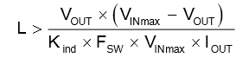

Where,

• VIN max = maximum input voltage

• VOUT = desired output voltage

• IOUT = desired maximum output current

• FSW = switching frequency of the converter

• Kind = estimated coefficient that represents the amount of inductor ripple current relative to the maximum output current.

A good estimation for the inductor ripple current is 20% to 40% of the output current, or 0.2 < Kind < 0.4.

**Boost Mode**

For boost mode the following equation is a good estimate for the right inductance:

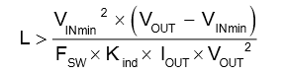

where • VIN min = minimum input voltage • VOUT = desired output voltage • IOUT = desired maximum output current • FSW = switching frequency of the converter • Kind = estimated coefficient that represents the amount of inductor ripple current relative to the maximum output current.

A good estimation for the inductor ripple current is 20% to 40% of the output current, or 0.2 < Kind < 0.4.

**Calculating Maximum Switch Current**

**Buck Mode:**

In buck mode, the maximum switch current is when the input voltage is at its maximum, the maximum switch current can be calculated.

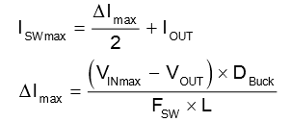

Where,

• VIN max = maximum input voltage

• VOUT = desired output voltage

• IOUT = desired output current

• ΔImax = maximum ripple current through the inductor

• ISW max = maximum switch current

• D-Buck = minimum duty cycle for buck mode

• FSW = switching frequency of the converter

• L = selected inductor value

To obtain the switching frequency, refer to the datasheet for the given converter.

Before continuing, verify that the converter can deliver the maximum current. Imax out must be greater than Iout.



Where,

• Imax out = maximum deliverable current through inductor by the converter.

• ILIM = switch current limit, specified in converter datasheet.

• ΔImax = Ripple current through the inductor calculated.

**Boost Mode:**

In boost mode, the maximum switch current is when the input voltage is at its minimum, the maximum switch current can be calculated.

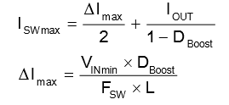

Where,

• VIN min = minimum input voltage

• VOUT = desired output voltage

• IOUT = desired output current

• ΔImax = maximum ripple current through the inductor

• ISW max = maximum switch current

• DBoost = maximum duty cycle for boost mode

• FSW= switching frequency of the converter

• L = selected inductor value

To obtain the switching frequency, refer to the datasheet for the given converter.

Before continuing, verify that the converter can deliver the maximum current. Imax out must be greater than Iout max. Iout max is specified as the maximum output current required be the application.

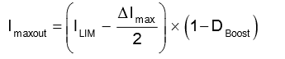

Where,

• Imax out = maximum deliverable current through inductor by the converter

• DBoost = maximum duty cycle for boost mode

• ILIM = switch current limit, specified in converter datasheet

• ΔImax = Ripple current through the inductor calculated.

**Components selection:**

**Select the Inductor**

The next step is to select the required inductance. If the inductance range is not limited by the IC you can

estimate the required inductance based on the well-known differential equation: L1 = VI D

I(L1)(PP) f(SW)

The **average inductor current I(L1)(AV)** is calculated by:

I(L1) (AV ) = IO

1 – D

in the data sheet. In this case, use the recommended value and calculate the **inductor current ripple**

**I(L1)(PP)** which is a rearrangement of above Equation :

I(L1) (PP) = VI(min)D

f(SW)L1

The **maximum inductor current I(L1)M** is the sum of the average component and the half of the peak-to-peak inductor current ripple and is as well the maximum switch current shown.

I(L1)M = I(SW)M = I(L1)(AVG) +I(L1) (PP)

2

As soon as switch S1 opens the energy is transferred to the output.

This means that the output voltage flies back to the switching node and the **voltage across the inductance V(L1)** becomes the output voltage minus the voltage drop of the diode: V(L1)M = VO – VF.

Vice versa, the **maximum voltage V(L1)M** is defined as the maximum output voltage minus the voltage dropof the diode.

**Select the Rectifier Diode**

For selecting the appropriate diode, consider that it needs to withstand the following stress parameters:

1. Average current: IF(AV) = IOM

2. Maximum peak current: IFRM = I(SW)M

3. Maximum DC reverse voltage: VR = VO – VI(min)

4. Power dissipation: PD = IOM × VF

Generally, TI recommends using Schottky diodes for inductive low- to middle-power DC/DC converters. This is due to the low forward voltage drop which leads to higher efficiency.

**5 Select the Capacitors**

In the buck-boost topology, the input and the output currents are pulsed. The choice of the input and output capacitances is therefore crucial to ensure stable performance. When choosing capacitors, take into account that the capacitance of ceramic capacitors decreases with its applied voltage, also called the DC Bias Effect.

**Introduction to Closed Loop Control of Buck Boost Converter:**

**Buck Boost Converter**is a converter which converts variable DC voltage to required DC voltage. Buck Boost converter is used to get DC output voltage greater than input voltage or lesser than the input voltage. Closed loop control is a process by which the output voltage is stabilized by obtaining the feedback of the loop. Closed loop control of Buck Boost Converter is used to obtain a constant DC output voltage. The switching frequency and duty cycle decides the output voltage. In the closed loop process the output voltage is compared with a set voltage and the error value is reduced by controlling the switching pulse.

## MATLAB Simulink Block Diagram for Closed Loop Control of Buck Boost Converter

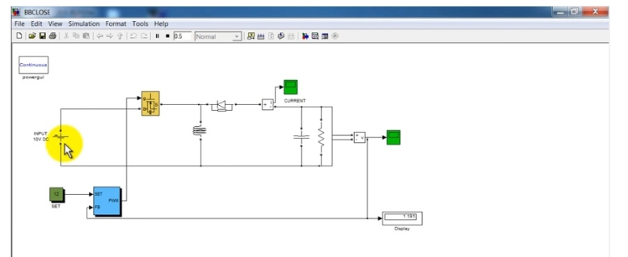

**2.2 SWITCHING REGULATOR**

The LM2576 series of regulators are monolithic integrated circuits ideally suited for easy and convenient design of a step−down switching regulator (buck converter). All circuits of this series are capable of driving a 3.0 A load with excellent line and load regulation. These devices are available in fixed output voltages of 3.3 V, 5.0 V, 12 V, 15 V, and an adjustable output version. These regulators were designed to minimize the number of external components to simplify the power supply design. Standard series of inductors optimized for use with the LM2576 are offered by several different inductor manufacturers. Since the LM2576 converter is a switch−mode power supply, its efficiency is significantly higher in comparison with popular three−terminal linear regulators, especially with higher input voltages. In many cases, the power dissipated is so low that no heatsink is required or its size could be reduced dramatically. A standard series of inductors optimized for use with the LM2576 are available from several different manufacturers. This feature greatly simplifies the design of switch−mode power supplies. The LM2576 features include a guaranteed ±4% tolerance on output voltage within specified input voltages and output load conditions, and ±10% on the oscillator frequency (±2% over 0°C to 125°C). External shutdown is included, featuring 80 A (typical) standby current. The output switch includes cycle−by−cycle current limiting, as well as thermal shutdown for full protection under fault conditions.

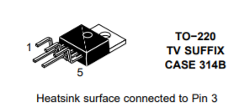

**Features:**

• 3.3 V, 5.0 V, 12 V, 15 V, and Adjustable Output Versions

• Adjustable Version Output Voltage Range, 1.23 to 37 V ±4% Maximum Over Line and Load Conditions

• Guaranteed 3.0A Output Current

• Wide Input Voltage Range

• Requires Only 4 External Components

• 52 kHz Fixed Frequency Internal Oscillator

• TTL Shutdown Capability, Low Power Standby Mode

• High Efficiency

• Uses Readily Available Standard Inductors

• Thermal Shutdown and Current Limit Protection

• Moisture Sensitivity Level (MSL) Equals 1

• Pb−Free Packages are Available

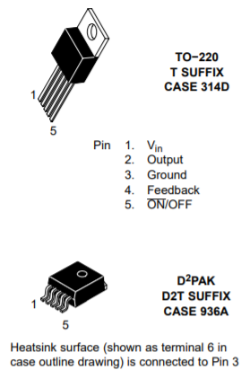

**Applications:**

* Simple High−Efficiency Step−Down (Buck) Regulator
* More efficient than Linear Regulators
* On−Card Switching Regulators
* Positive to Negative Converter (Buck−Boost)
* Negative Step−Up Converters
* Power Supply for Battery Chargers
* Less Heat dissipation

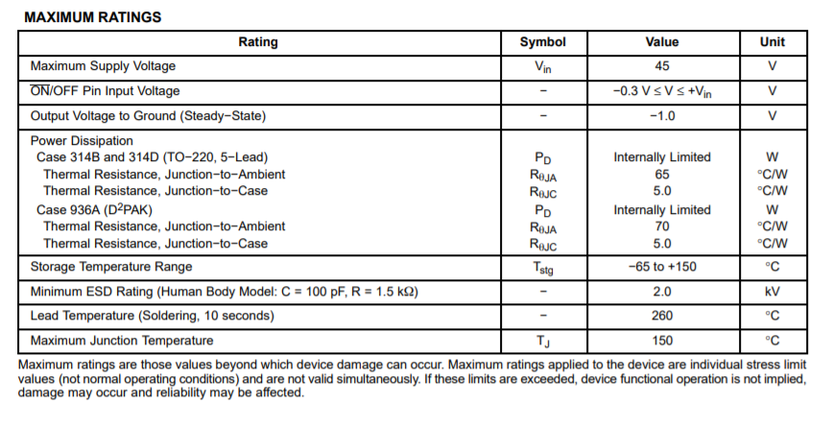

**OPERATING RATINGS:** (Operating Ratings indicate conditions for which the device is intended to be functional, but do not guarantee specific performance limits. For guaranteed specifications and test conditions, see the Electrical Characteristics.)

**LM2576−5**

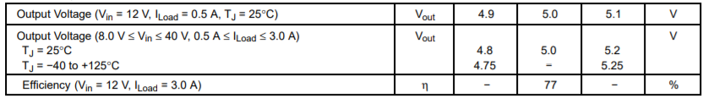

1. External components such as the catch diode, inductor, input and output capacitors can affect switching regulator system performance. When the LM2576.

2. Tested junction temperature range for the LM2576: T(low) = −40°C, T(high) = +125°C.

3.The oscillator frequency reduces to approximately 18 kHz in the event of an output short or an overload which causes the regulated output voltage to drop approximately 40% from the nominal output voltage. This self-protection feature lowers the average dissipation of the IC by lowering the minimum duty cycle from 5% down to approximately 2%.

4. Output (Pin 2) sourcing current. No diode, inductor or capacitor connected to output pin.

5. Feedback (Pin 4) removed from output and connected to 0 V.

6. Feedback (Pin 4) removed from output and connected to +12 V for the Adjustable, 3.3 V, and 5.0 V versions, and +25 V for the 12 V and 15 V versions, to force the output transistor “off”.

7. Vin = 40 V.

**TYPICAL TEST CIRCUIT:**

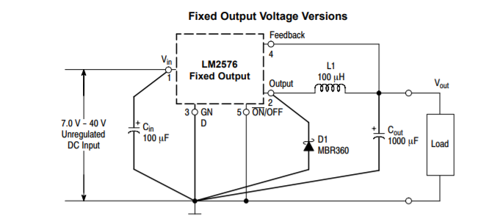

**TYPICAL PERFORMANCE CHARACTERISTICS:**

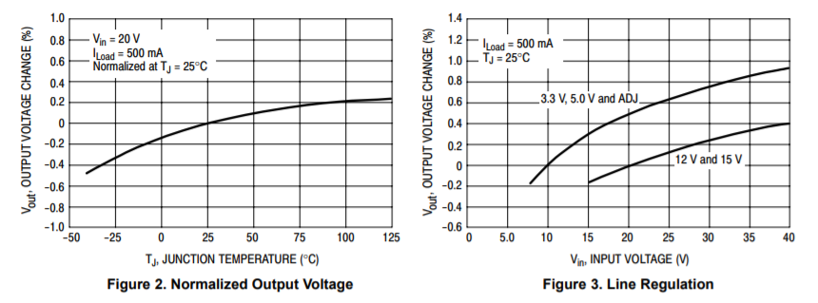

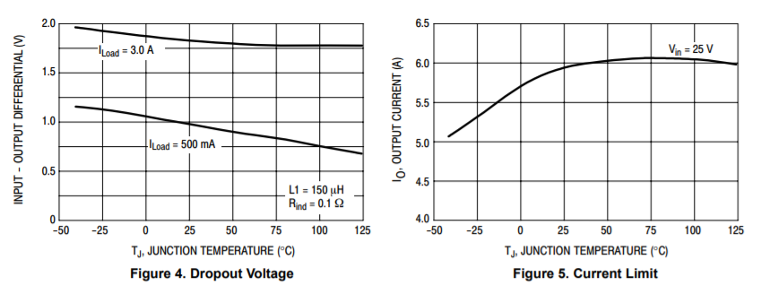

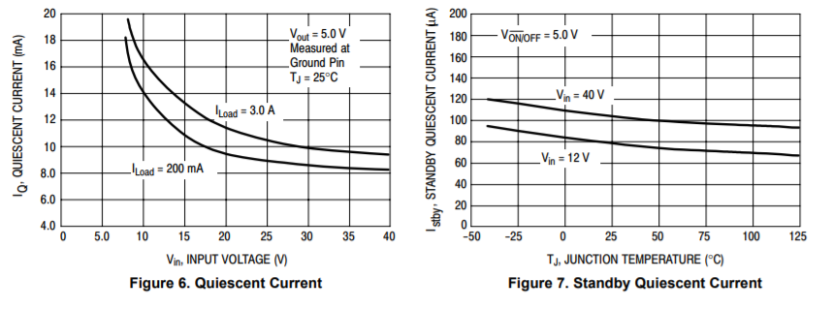

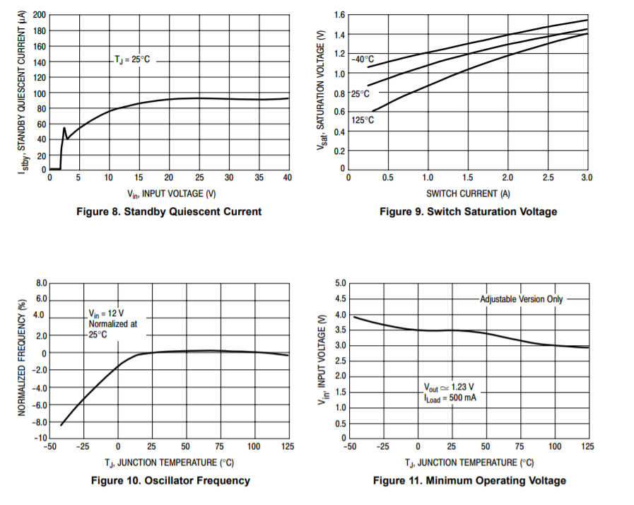

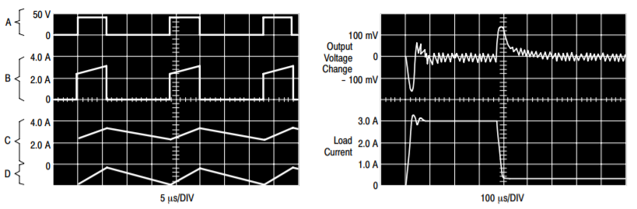

**SWITCHING WAVEFORMS LOAD TRANSIENT RESPONSE**

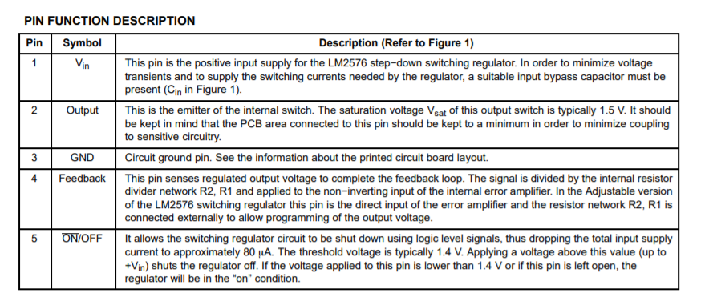

**LM2576 Series Buck Regulator Design Procedures**

The LM2576 is a “Buck” or Step−Down Converter which is the most elementary forward−mode converter. The operation of this regulator topology has two distinct time periods. The first one occurs when the series switch is on, the input voltage is connected to the input of the inductor. The output of the inductor is the output voltage, and the rectifier (or catch diode) is reverse biased. During this period, since there is a constant voltage source connected across the inductor, the inductor current begins to linearly ramp upwards, as described by the following equation:



During this “on” period, energy is stored within the core material in the form of magnetic flux. If the inductor is properly designed, there is sufficient energy stored to carry the requirements of the load during the “off” period.

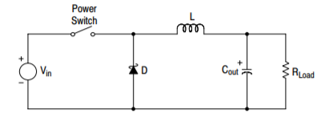

The next period is the “off” period of the power switch. When the power switch turns off, the voltage across the inductor reverses its polarity and is clamped at one diode voltage drop below ground by the catch diode. The current now flows through the catch diode thus maintaining the load current loop. This removes the stored energy from the inductor. The inductor current during this time is:

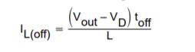

This period ends when the power switch is once again turned on. Regulation of the converter is accomplished by varying the duty cycle of the power switch. It is possible to describe the duty cycle as follows:



For the buck converter with ideal components, the duty cycle can also be described as:



Below shows the buck converter, idealized waveforms of the catch diode voltage and the inductor current.

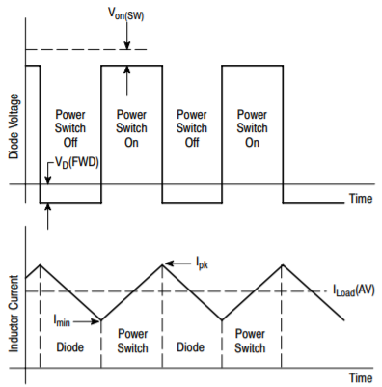

**Procedure (Fixed Output Voltage Version)** In order to simplify the switching regulator design, a step−by−step design procedure and some examples are provided.

|  |  |
| --- | --- |
| **Procedure** | **Example** |
| **Given Parameters**:  Vout = Regulated Output Voltage (3.3 V, 5.0 V, 12 V or 15 V)  Vin(max) = Maximum Input Voltage  ILoad(max) = Maximum Load Current | **Given Parameters:**  Vout = 5.0 V  Vin(max) = 15 V  ILoad(max) = 3.0 A |
| **1. Controller IC Selection** According to the required input voltage, output voltage and current, select the appropriate type of the controller IC output voltage version | **1. Controller IC Selection** According to the required input voltage, output voltage, current polarity and current value, use the LM2576−5 |
| **2. Input Capacitor Selection (Cin)** To prevent large voltage transients from appearing at the input and for stable operation of the converter, aluminium or tantalum electrolytic bypass capacitor is needed between the input pin +Vin and ground pin GND. This capacitor should be located close to the IC using short leads. This capacitor should have a low ESR (Equivalent Series Resistance) value. | **2. Input Capacitor Selection (Cin)** A 100 F, 25 V aluminium electrolytic capacitor located near to the input and ground pins provides sufficient bypassing. |
| **3. Catch Diode Selection (D1)**  **A.** Since the diode maximum peak current exceeds the regulator maximum load current the catch diode current rating must be at least 1.2 times greater than the maximum load current. For a robust design the diode should have a current rating equal to the maximum current limit of the LM2576 to be able to withstand a continuous output short **B.** The reverse voltage rating of the diode should be at least 1.25 times the maximum input voltage. | **3. Catch Diode Selection (D1)**  **A.** For this example the current rating of the diode is 3.0 A.  **B.** Use a 20 V 1N5820 Schottky diode, or any of the suggested fast recovery diodes. |
| **4. Inductor Selection (L1)**  **A.** According to the required working conditions, select the correct inductor value using the selection guide  **B.** From the appropriate inductor selection guide, identify the inductance region intersected by the Maximum Input Voltage line and the Maximum Load Current line. Each region is identified by an inductance value and an inductor code.  **C.** Select an appropriate inductor from the several different manufacturers. Designer must realize that the inductor current rating must be higher than the maximum peak current flowing through the inductor. This maximum peak current can be calculated as follows: | **4. Inductor Selection (L1)**  **A.** Use the inductor selection guide  **B.** From the selection guide, the inductance area intersected by the 15 V line and 3.0 A line is L100.  **C.** Inductor value required is 100 H. choose an inductor from any of the listed manufacturers. |
| **5. Output Capacitor Selection (Cout)**  **A.** Since the LM2576 is a forward−mode switching regulator with voltage mode control, its open loop 2−pole−1−zero frequency characteristic has the dominant pole−pair determined by the output capacitor and inductor values. For stable operation and an acceptable ripple voltage, (approximately 1% of the output voltage) a value between 680 F and 2000 F is recommended.  **B.** Due to the fact that the higher voltage electrolytic capacitors generally have lower ESR (Equivalent Series Resistance) numbers, the output capacitor’s voltage rating should be at least 1.5 times greater than the output voltage. For a 5.0 V regulator, a rating at least 8.0 V is appropriate, and a 10 V or 16 V rating is recommended. | **5. Output Capacitor Selection (Cout)**  **A.** Cout = 680 F to 2000 F standard aluminium electrolytic. **B.** Capacitor voltage rating = 20 V. |

**DIODE SELECTION GUIDE:**

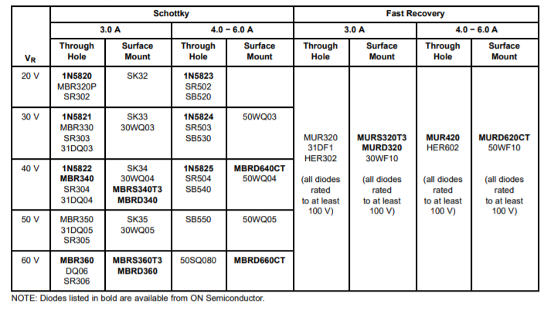

**Indicator Value Selection Guide:**

**LM2576−5**

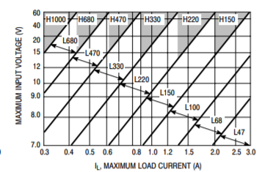

**Catch Diode:**

**Locate the Catch Diode Close to the LM2576** The LM2576 is a step−down buck converter; it requires a fast diode to provide a return path for the inductor current when the switch turns off. This diode must be located close to the LM2576 using short leads and short printed circuit traces to avoid EMI problems.

**Use a Schottky or a Soft Switching Ultra−Fast Recovery Diode** Since the rectifier diodes are very significant sources of losses within switching power supplies, choosing the rectifier that best fits into the converter design is an important process. Schottky diodes provide the best performance because of their fast switching speed and low forward voltage drop. They provide the best efficiency especially in low output voltage applications (5.0 V and lower). Another choice could be Fast−Recovery, or Ultra−Fast Recovery diodes. It has to be noted, that some types of these diodes with an abrupt turnoff characteristic may cause instability or EMI troubles. A fast−recovery diode with soft recovery characteristics can better fulfill some quality, low noise design requirements. Table 1 provides a list of suitable diodes for the LM2576 regulator. Standard 50/60 Hz rectifier diodes, such as the 1N4001 series or 1N5400 series are NOT suitable.

**Inductor** The magnetic components are the cornerstone of all switching power supply designs. The style of the core and the winding technique used in the magnetic component’s design has a great influence on the reliability of the overall power supply. Using an improper or poorly designed inductor can cause high voltage spikes generated by the rate of transitions in current within the switching power supply, and the possibility of core saturation can arise during an abnormal operational mode. Voltage spikes can cause the semiconductors to enter avalanche breakdown and the part can instantly fail if enough energy is applied. It can also cause significant RFI (Radio Frequency Interference) and EMI (Electro−Magnetic Interference) problems.

**Selecting the Right Inductor Style** Some important considerations when selecting a core type are core material, cost, the output power of the power supply, the physical volume the inductor must fit within, and the amount of EMI (Electro−Magnetic Interference) shielding that the core must provide. The inductor selection guide covers different styles of inductors, such as pot core, E−core, toroid and bobbin core, as well as different core materials such as ferrites and powdered iron from different manufacturers. For high quality design regulator the toroid core seems to be the best choice. Since the magnetic flux is contained within the core, it generates less EMI, reducing noise problems in sensitive circuits. The least expensive is the bobbin core type, which consists of wire wound on a ferrite rod core. This type of inductor generates more EMI due to the fact that its core is open, and the magnetic flux is not contained within the core.

**THE LM2576−5 STEP−DOWN VOLTAGE REGULATOR WITH 5.0 V @ 3.0 OUTPUT POWER CAPABILITY. TYPICAL APPLICATION WITH THROUGH−HOLE PC BOARD LAYOUT**

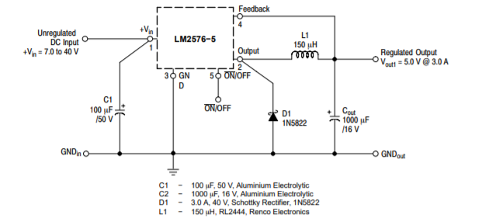

**Applications:**

1. Relatively small size allows mobile use (ideal for camping and other recreation).

2. System requires no electrical start-up power.

3. Low maintenance, emission-free and environmental-friendly power source.

**Advantages:**

* spikes of output for charging.
* Utilize renewable sources.
* Bring convenience to the users.
* Useful for users in remote area & Portable for travelers.
* To save the electricity bill cost in the long run.
* Reduce environmental pollution.

**Disadvantages:**

* Cost is high.
* It is also applies the portable device.
* Charger is different type such as-Laptop , cell phone & MP3 player.
* Solar charger have no capacity to store the energy.
* They are only for use of small amount of time.
* It will not work in cloudy day.
* It may not be ideal in your situation.

**Conclusion:**

* In solar mobile charger ripples will not be there as we use DC
* power directly to charge the mobile.
* Battery life is more as high voltages are not developed.
* Versatility of Solar mobile charger is high.
* Life of the battery will be high as we use solar mobile charger.
* Adaptability is high.